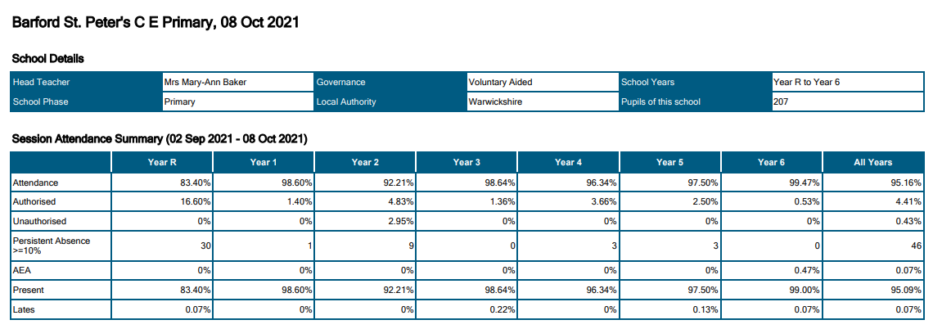
Attendance Report & Summary

- Reception is currently at 83% due to the staggered start to the year. This was to allow children to settle appropriately into the school. This is reflected by authorised absences showing at 16.6%.
- Year 2 is currently at 92.21% due to two siblings having a period of absence from school due to exceptional circumstances relating to family members.
- All figures are lower than expected due to COVID cases within the school. There have been instances where children have isolated at home due to family members having COVID. This has been the decision of the families and supported by the school, to help reduce and prevent the spread of COVID within classrooms.

We expect all attendance figures to increase over the average of the academic year. Below are the previous year’s figures; these are still lower than expected due to a year disrupted by COVID.

Attendance during academic year 2020/21

Year Group | Attendance
Reception | 99%
1 | 98.17%
2 | 97.9%
3 | 98.4%
4 | 98.17%
5 | 98.84%
6 | 97.71%

