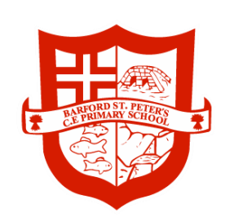

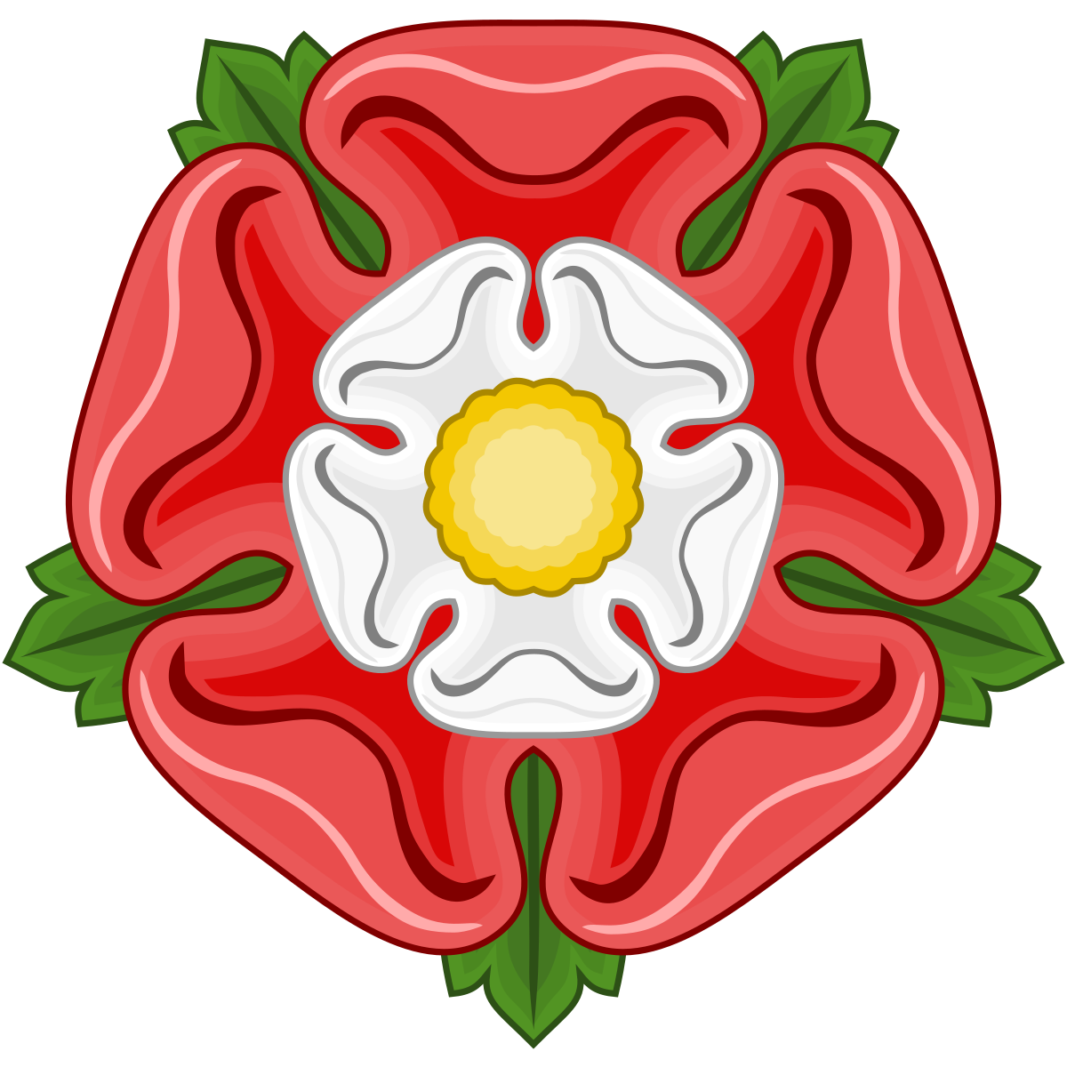

Year 6 Autumn 1 Term 2023
Tudor Warwickshire

Dear Parents,

I hope you are well and have all had a lovely summer break with your families. I am certainly excited for the new academic year ahead. Our new learning theme for this half term will be ‘Tudor Warwickshire’. Below is an outline of what we will be learning and ways you can help at home.

Supporting learning at home:

- Encourage your child to read every day and record this in their reading record. We would love children to access a range of genres in their reading at home, including poetry, non-fiction and fiction.
- Support and encourage your child to learn their spellings each week; little and often is best. I will also be sending out a list of all of the Key Stage 2 statutory spellings which are organized by their spelling rule. If you could support your child to practice these alongside their weekly spellings this will help them to apply them in their own writing more successfully (as well as supporting them to prepare for the end of year statutory GPS test).
- Practise times tables up to 12 x 12 with your child as often as you possibly can. In order to access all maths areas to the fullest, children need to be able to quickly recall all their multiplication and division facts with speed.
- Help your child to tell the time by asking them to read an analogue clock at various intervals throughout the day.

PE

- This half term their will be two different PE sessions taking place on Monday and Tuesday. On Monday morning the PE lesson will take place in school with an external coach. Please ensure your child comes into school wearing their school PE kit on this day. Our Tuesday PE lesson will be a Swimming lesson so please ensure that the children have the appropriate swimming kit this day.

Please remember to come and talk to us anytime if you need to discuss anything. We will be happy to answer any questions you have.

Best Wishes,

Miss Taylor and the Year 6 Team

English

In English, to inspire both our fiction and non-fiction writing, we will be delving into Shakespeare’s Macbeth: a dramatic play with themes of ambition, fate and free will.

Some of our writing opportunities this half-term will include:
- Writing a letter from Macbeth to Lady Macbeth to inform her of the witches’ prophecies.
- Writing a persuasive monologue in role as the devious Lady Macbeth as she tries to persuade her husband to commit a horrific crime.
- Writing a soliloquy to convey Macbeth’s innermost thoughts as he grapples with the idea of murdering King Duncan.
- Creating a gruesome recipe inspired by the Three Weird Sisters.
- A balanced argument considering whether King Henry VIII was a good king.

In Guided Reading, as well as enjoying some classic poetry, we will be looking closely at an adapted version of Macbeth to develop our vocabulary, retrieval and inference skills and to examine the author’s choices and intent in detail.

Examples of texts which support the learning in our topic are:
- Modern translations of Macbeth/narrative versions
- Other Shakespeare plays/narrative versions
- Non-fiction texts based on the Tudor period
- Treason by Berlie Doherty (our focus text for next half term)
- The Queen’s Fool by Ally Sherrick
- My Friend Walter by Michael Morpurgo

Maths

In Maths we will learn to:
- read, write and represent numbers to ten million (10,000,000)
- multiply and divide by powers of 10 (including problem solving)
- recognise values on a number line to 10,000,000
- compare and order integers up to 10,000,000
- round any number to the nearest 1,000, 10,000, 100,000, 1,000,000
- understand negative numbers
- add and subtract whole numbers with more than 4 digits (column method)
- use inverse operations
- find common factors and common multiples
- understand rules of divisibility
- find prime numbers
- find square and cube numbers
- multiply up to a 4-digit number by a 2-digit number

Art
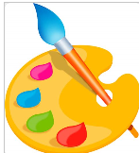
In our Visual Art lessons we will be exploring tonal shading using both sketch pencils and paints. We will experiment with different techniques for creating depth and the illusion of 3D form on a flat canvas. We will also be exploring tints and shades to create a monochromatic colour walk in our sketchbooks. Moving on to explore sculpture through modelling we will create a clay bust of Henry VIII using the ‘slip and score’ technique to attach all elements of the sculpture.

Science
In Science our focus will be ‘Light’.
We will learn that light appears to travel in straight lines
and use the idea that light travels in straight lines to explain that objects are seen because they give out or reflect light into the eye. We will use our scientific knowledge to explain why shadows have the same shape as the objects that cast them and how the size of shadows can be altered (elongated or shortened) . We will also use our observational skills to explore the concept of refraction and learn how Isacc Newton used a prism to separate light into all the colours of the spectrum.

Relationships & Health Education

Our topic this term will be ‘Protective Behaviours.’ We will be thinking about who we can speak to when we get our early warning signs and creating Network Hands to represent these people. We will think carefully about how we can ensure we feel safe and heard.

RE

In RE we will be considering how different religions can offer support when life gets hard. Within this topic we will be considering religious beliefs in life after death and discussing what we think is meant by a person’s soul.

Music

In Music, we will be tuning into our “Feel Good Friday”music sessions provided by Rocksteady Music. During these sessions, we will explore the different elements of music through creative, interactive activities.

Computing

In Computing, we will be learning the fundamentals of the programming language of Python. We will test, change and explain what our program does. We will also use loops and explain what repeats do. We will then decompose programs into algorithms.

P.E.

This half term we will have PE sessions on Monday and Tuesday morning. Monday lessons will be taught by an external coach at school and on Tuesdays we will be going swimming. Please ensure you have the correct PE kit for each of these days.

History

In History we will be learning about Tudor Warwickshire. This will include learning about the War of Roses and the beginning of the Tudor reign. We will learn about each of the monarchs and consider the impact their rule had on the lives of Warwickshire civilians. We will also be debating whether Henry VIII was an effective monarch or merely a merciless tyrant. Integral to our history lessons will be comparing and contrasting both primary and secondary historical sources of evidence as well as considering their reliability.

