

Year 4 Spring Term 2024

The Romans in Britain

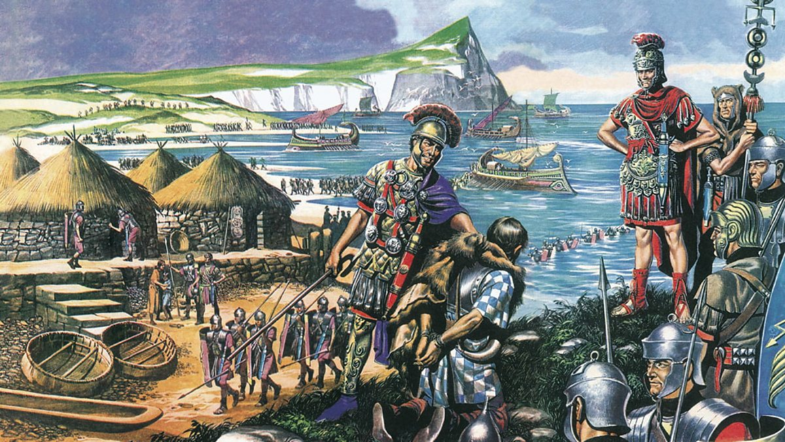

Dear Parents,
Happy New Year to you all! I hope you had a wonderful Christmas break and are settling into 2024.

This very short term will have two concurrent topics running throughout the 10 weeks: The Romans in Britain and Electricity. This first half term will see us focus more on the Romans, and I’m delighted that we have a visitor from Get The Specialists coming in to lead a Romans day on Wednesday 17th January to provide the children with an exciting introduction to this topic.

After half term, when the focus will switch more to Electricity, we have a visit planned to the Think Tank museum in early March. As well as exploring all the exhibits and deepening our understanding of a wider range of science topics, we are booked into an Electrifying Science workshop where we will look in greater detail at discoveries throughout history which led to our current understanding of electricity (pun very much intended).

I’m incredibly grateful for your support with the children’s education, and I know we are going to have another incredibly successful and fascinating term of learning and discovery!

Supporting learning at home:

- Encourage your child to read every day. We would love children to access a range of genres in their reading at home, including poetry, non-fiction and fiction.

- I’m delighted to have had some many children engaging with our Books to Read in Year 4! Thank you for encouraging your child with this, and the aim would be to have read four of the six books before Easter. We do have limited copies of each book in school for the children to borrow and take home to help them achieve this goal.

- In KS2, we are continuing the weekly reward of an extra break time on a Friday for any children who complete their homework and hand it in on time.
Each class teacher will set their own criteria for earning this reward, and Year 4’s is as follows:
- Completing that week’s maths homework and handing it in on time
- Clear evidence that they are working on their times tables (usually by improving their score in the weekly times tables test)

- Support and encourage your child to learn their spellings each week; little and often is best. Our weekly spelling test will continue to be on Wednesdays, and the spelling lists will either be on Google Classroom or written into your child’s book.

- Children will continue to be set one piece of maths homework to complete each week. Whilst I would encourage the children to complete this independently, please feel free to support your child with their homework. If there is anything they don’t understand, please ask your child to come and speak to me for additional help before the homework is due in.

Dates for the Diary

- Wednesday 17th January – Year 4’s Roman Experience Day (in school)
- Wednesday 7th & Thursday 8th February – Parent-Teacher Meetings

Each week

- This half term, children will have swimming on Tuesdays and P.E. on Thursdays. Please help to ensure they have the correct kit in school on these days.
- Spelling tests will be every Wednesday.
- Times table test will be every Friday.
- Homework will be set on a Thursday and due in on the following Tuesday.

Please remember to come and talk to us anytime if you need to discuss anything.

Mr. Sewards & Mrs. McWhirter

English

In English we will be learning to:

- Use subordinate clauses in sentences
- Rearrange clauses for effect
- Write setting and character descriptions
- Further develop their vocabulary
- Include effective dialogue in their writing
- Punctuate speech accurately
- Read a wider range of genres
- Be able to answer a wider range of reading comprehension questions

Maths

In maths, we will be learning the following skills through a range of fluency and reasoning & problem solving activities:

- To recall times table and division facts up to 12x12
- Use short multiplication method
- Use short division method
- Calculate the area of rectangles and rectilinear shapes
- Tackle maths investigations based on their knowledge of multiplication and division

Science



We will begin with a short unit on states of matter before our longer topic about circuits and electricity. This will involve making circuits and exploring the use of different components.

Spanish


We are delighted to have Mrs. Del Rio teaching our Spanish this year. She will be planning and co-ordinating the curriculum, and will begin by going over key Spanish greetings and conversation.

Art


We will be looking at continuous line drawing, including some works by Picasso. We will explore different techniques and use them to create artwork in our chosen style.



Geography


In conjunction with our work in history on the Romans, we will be looking at which modern-day towns and cities existed in Roman Britain, as well as how their transport network was created and built upon by future generations.

Computing



This term will be focused on Online Safety, including how to discern the accuracy of information, what a bot is, ways people influence others to buy things online, and how to monitor our screen-time.

History


Our Romans in Britain topic will include why the Romans chose to invade Britain, some of the technologies and ways of life they brought, and how the impact of their civilisation can still be seen in the modern day.

R.E.



In RE, we will be considering why some people think life is a journey. In this unit, we will explore some of the key “life” ceremonies of Christians, Jews and Hindus, such as baptism, bar/bat-mitzvah and marriage.

P.S.H.E


Our topic this half term will be based on developing our independence to look after our physical and mental wellbeing, including dental hygiene, mindfulness and ways to manage our emotions.

P.E.


Our P.E. will be led by specialist coaches this half term. On Tuesdays, we will be swimming with Everyone Active, and on Thursday we will be going gymnastics with Miss Ruby.

