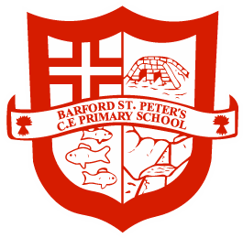

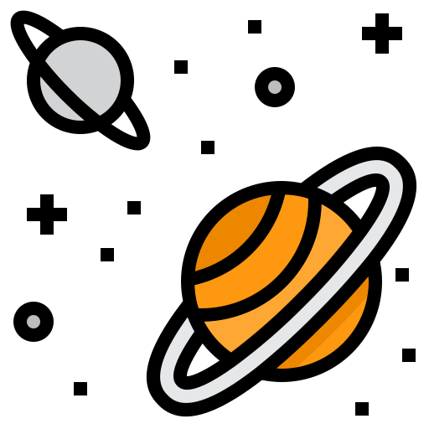

Year 2 Spring Term 1
Space

Curriculum Letter
Dear Parents,

Firstly, thank you so much for your incredibly generous gifts at Christmas. The year 2 team were very touched by your generosity and kindness. We hope you had a great break and that the children are rested and ready for an exciting term! I will be trying to make the most of my final few weeks with your children before leaving to go on maternity leave. I’m going to miss them all lots! Our topic for this half term is 'Space'. We will be looking at the planets in our solar system, the history of the moon landings, Neil Armstrong and what makes our precious planet so special.

Supporting learning at home:

- Encourage your child to read every day and record this in their reading record book. We would love children to access a range of genres in their reading at home, including poetry, non-fiction and fiction.
- Support and encourage your child to learn their weekly spellings; little and often is best. Please find attached the spellings for this half term as well as a list of common exception words. It will be beneficial for the children to be able to read and spell all of these words by the end of the academic year.
- Please continue to consolidate counting in 2s, 5s and 10s with your child, as well as addition facts to 10, 20 or 100 and the related subtraction facts; eg: 16 + 4 = 20 so 20 – 16 = 4.
- Encourage your child to write for a purpose, for example shopping lists or diaries.
- Engage in measuring activities through practical activities such as cooking.

Homework
Homework will be sent out on a Thursday and is due in the following Tuesday. It will consist of reading, spellings, a piece of maths work and a piece of English work which will be a reading comprehension. Your child’s maths homework will now be online on Education City and TT Rockstars. The expectation will be that children complete the maths task on Education City as well as spending 10-15 minutes on TT Rockstars each week (as a minimum). If you have any issues or questions about the homework at any point please drop me an email.

Reading Books
Children’s reading books will be changed each Tuesday. They will bring some 2 books each week. Please ensure that you record in children’s reading diaries and keep the reading books in their book bags every day. It is really important that the children read the same book multiple times to build up fluency and confidence and to help children to be able to contribute any comprehension discussions you might have with them.

Dates for the Diary
Movie night – Friday 26th January
Parents’ meetings – TBC (these will most likely be commencing the week beginning 29th January)
Safer Internet Dat – Tuesday 6th February
Year 2 Cake Sale – Friday 9th February

P.E. Kits
Our P.E. sessions will be on a Monday afternoon and a Wednesday afternoon so children will need their P.E. kits for those days. We will be outside on a Wednesday so make sure you’ve got warm clothes!

Library Books
Each Friday, children will have the opportunity to bring home a library book to share with you. Please return these each Friday so that they can swap their book for a new one. This is in addition to the school reading books.

Please feel free to email or speak to me if you have any questions or worries. Our class email address is year2@barfordstpeters.co.uk.

Best Wishes
Mrs Feldman

English

In English we will be learning to:
- We will be writing a narrative about what it might be like to live on the moon. We will be using 'Man on the Moon' by Simon Bartram as our inspiration.
- We will also be writing a newspaper report about the Apollo 11 moon landing.
- In guided reading, we will also be using texts linked to our topic such as Beegu
- In grammar, we will be covering nouns, adjectives, expanded noun phrases, questions and commands and homophones.

Examples of stories you could share with your child at home which relate to our topic include:

- Aliens Love Underpants by Claire Freedman & Ben Carl
- Curiosity: The Story of a Mars Rover by Markus Motum
- A Journey Through: Space by Steve Parker & John Haslam
- The Skies Above My Eyes by Charlotte Guillain & Yuval Zommer
- Space Poems by Gaby Morgan
- Beegu by Alexis Deacon
- An Alien in the Jam Factory by Chrissie Sands
- Hidden Figures by Margot Lee Shetterly

Maths

In maths we will be learning to:
- Recall and use multiplication and division facts for the 2, 5 and 10 multiplication tables, Including recognising odd and even numbers.
- Calculate mathematical statements for multiplication and division within the multiplication tables and write them using the multiplication, division and equals signs.
- Show that multiplication of two numbers can be done in any order and division of one number by another cannot.
- Solve problems using multiplication and division using different materials and approaches such as arrays, repeated addition, mental methods and problems in context.

Geography
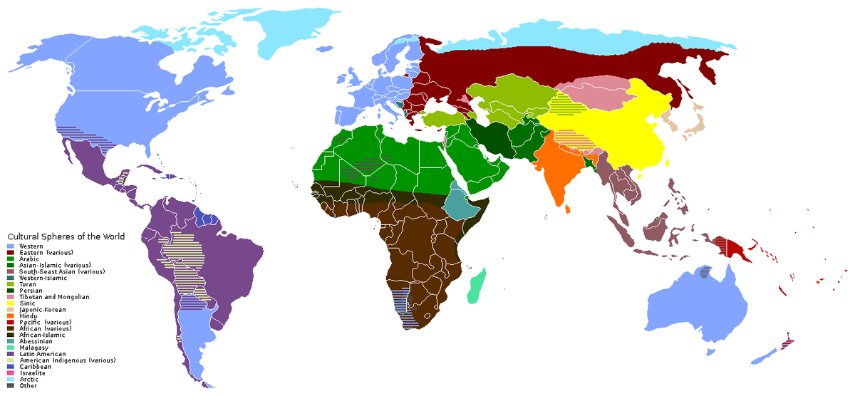
We will be focusing on planet Earth In our geography lessons. We’ll be locating the 7 continents and looking closely at a globe to identify the Northern and Southern Hemisphere. We will explore the characteristics of the 7 continents that make up our world and the oceans that surround them. We will also be looking at the human and physical features of some of the most Important cities in the world.

Art and D.T.

In art we will be using pastel to experiment with line, shape, pattern and colour. We will be creating Images of the planets as part of this exploration. We will also be using weaving techniques to create our own planets. We will be exploring with texture by using paste, charcoal and chalk to create a piece of art that looks just like the moon's surface.

Science



In Science, we will be looking different materials and their uses. We will be experimenting with squashing, bending, twisting and the stretching of different materials and discussing why certain materials are used for specific things.

Relationships & Health Education


In P.S.H.E. we will be continuing to look at family and relationships. Children will be understanding the role of the family In their lives as well as thinking about the range of families that exist In our country. We will also focus on understanding other's feelings and begin to understand that some friendships might make us feel unhappy.

P.E.
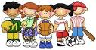

In P.E. we will be doing both dance and team sports! Miss Ruby will be doing dance with us. In our team sports sessions, we will be having a go at a few different sports and learning the rules to lots of different sports like hockey, netball, football and rugby.

R.E.

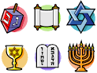

We will be learning about Muslims and what they believe in. We will be listening and responding to stories from the Muslim faith and about the Prophet Muhammed. We will also be virtually exploring mosque and learning about the things Muslims do there.

Computing


Our computing topic will focus on data handling. We will be using the International Space Station as inspiration for this. We will be collecting data, using it and displaying it in appropriate formats. This will also link with our Science topic and we will be learning about the conditions plants need to survive and creating an algorithm for this.

Music


In our music sessions we will be using our voices to sing a melody whilst also playing an instrument. We will be describing the dynamics of timbre of our pieces and be showing a range of emotions with our voices. We will be composing and performing pieces using different dynamics.



