

Year 4 Autumn Term 2024

The Romans in Britain

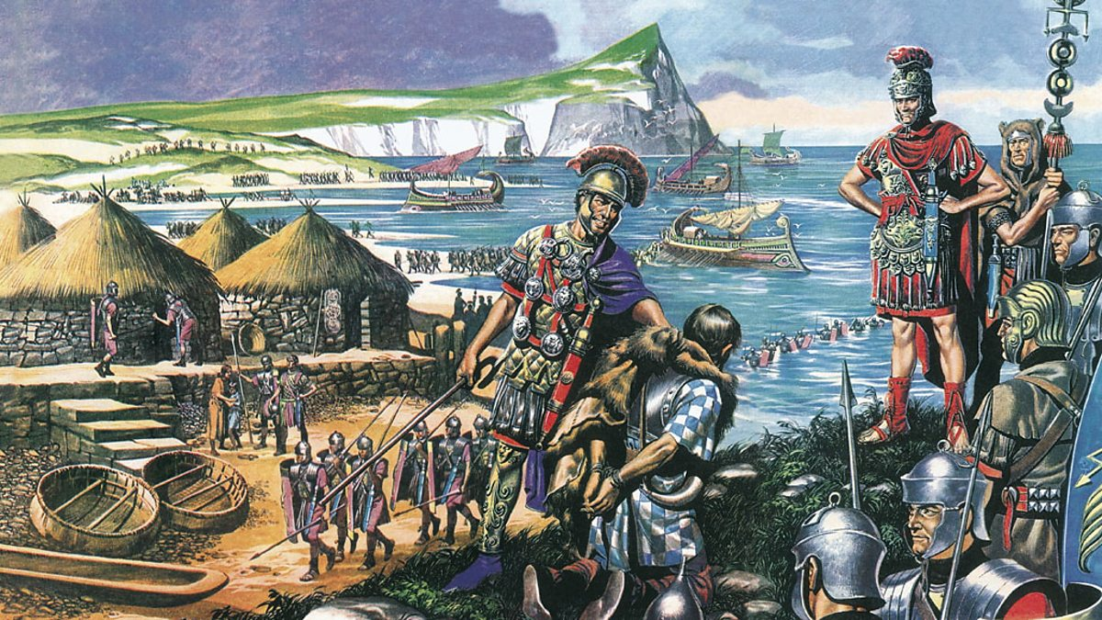

Dear Parents,

It has been an excellent start to Year 4, and I’m so grateful for your kind comments during parents’ evening about how much the children have enjoyed our topic on the Ancient Egyptians! We are so thankful that so many of you attended our class assembly, and I know the children thoroughly enjoyed performing for you all.

Our topic has now moved to looking at The Romans in Britain, where we will be discovering how and why the Romans invaded, what changes they brought to the country, as well as the legacy they left behind.

This half term is always one of the busiest, and this year will be no exception! We will also be rehearsing for the KS2 Christmas production throughout the half term. It promises to be another fantastic show and we can’t wait to welcome you along to see it!

Supporting learning at home:

- Encourage your child to read every day. We would love children to access a range of genres in their reading at home, including poetry, non-fiction and fiction. It would be wonderful if children could visit the library to research more about the Romans to further develop their understanding of the topic.

- Reading diaries need to be handed in on Tuesdays so they can be checked and signed.

- Support and encourage your child to learn their spellings each week; little and often is best. Our weekly spelling test will be on Wednesdays, and the spelling lists for this half term is available in your child’s pink homework book.

- Children will be set one piece of maths and one short reading comprehension to complete each week and hand in on Tuesdays. Whilst I would encourage the children to complete this independently, please feel free to support your child with their homework. If there is anything they don’t understand, please ask your child to come and speak to me for additional help before the homework is due in.

- On Fridays, each child will be testing their times tables learning in our 99 Club work. Each level has a different number of questions to complete in a five minute time period. As the children progress up the levels, more times tables are added and the number of questions is increased. To progress to the next level, a child must answer all the questions correctly within the five minutes.

To assist with their learning, children are expected to spend 30 minutes per week (ideally around five minutes most days) learning their tables. This can be done in any way which works for them, are there are a range of links to websites/games on Google Classroom.

Dates for the Diary

- Friday 15th November – Children in Need Day
- Wednesday 11th December – KS2 Christmas Panto Trip
- Wednesday 18th (5pm) and Thursday 19th December (2pm) – KS2 Christmas Production

Each week

- This half term, children will have P.E. on Mondays and Fridays. Monday PE sessions will be orienteering, so the children will need their outdoor clothes and appropriate footwear. Fridays will be hockey in usual school PE kit. Please help to ensure they have the correct kit in school on these days.
- Spelling tests will be every Wednesday.
- Times table test will be every Friday.
- Homework will be set on a Thursday and due in on the following Tuesday.

Please remember to come and talk to me anytime if you need to discuss anything.

Mr. Sewards

English

In English we will be learning to:

- Use apostrophes for possession
- Expand noun phrases regularly
- Using fronted adverbials
- Write a newspaper report
- To use suitable words and phrases to link and build cohesion between paragraphs
- Select and use suitable presentational and organisational features for an information text
- Read and appreciate a range of poetry

Maths

In maths, we will be learning the following skills through a range of fluency and reasoning & problem solving activities:

- Add and subtract numbers using the column method
- Tackle maths investigations based on their knowledge of number
- To recognise links between multiplying and dividing by 2, 4 and 8
- Recall multiplication and division facts in the 3, 6 and 9 times tables
- Tackle maths investigations based on their knowledge of addition and subtraction

Science



In our topic this half term, we will be exploring the first three states of matter, learning about how particles behave differently in these states, and how objects can change state.

Spanish


We are delighted to have Mrs. Del Rio teaching our Spanish this year. She will be planning and co-ordinating the curriculum, and will begin by going over key Spanish greetings and conversation.

Design Technology

We will be developing our sewing skills to make our own Christmas tree decorations. This will involve us using three different stitches, as well as learning how to combine different materials together.



Geography


In conjunction with our work in history on the Romans, we will be looking at which modern-day towns and cities existed in Roman Britain, as well as how their transport network was created and built upon by future generations.

Computing



This half term will begin our work to learn further coding skills on Scratch to develop what we learned in Year 3. These will include loops and learning to code triggers for sequential commands.

History


Our Romans in Britain topic will include why the Romans chose to invade Britain, some of the technologies and ways of life they brought, and how the impact of their civilisation can still be seen in the modern day.

R.E.



In RE, we will be finishing our work on Hinduism, looking at how our morals and ethics affect our ability to make decisions, and learning about the importance of Advent to Christians.

P.S.H.E


We will be learning about how to stay safe, our early warning signs and the rights and responsibilities we have as people in our ever-changing world.

P.E.


Our P.E. with Mr. Sewards this half term will be orienteering using our bespoke course and specially designed maps! With our P.E. coach, we will be taking part in hockey.

