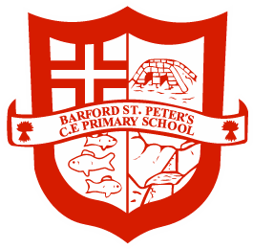

Year 4 Autumn Term 2024
Ancient Egypt

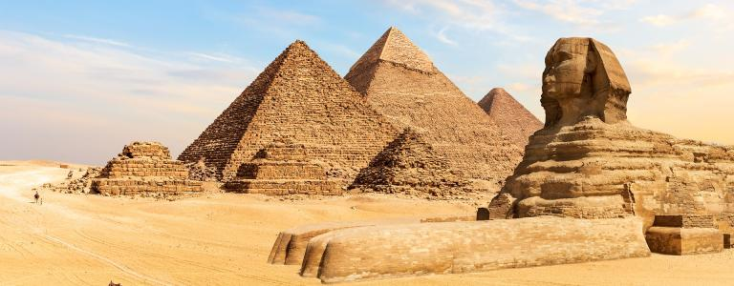

Dear Parents,

Welcome back to the new academic year! I’m incredibly excited to take on the responsibility of teaching this enthusiastic class, and I know we will have a terrific year full of quality learning.

Our new learning theme for most of this half term will be based on Ancient Egypt. We will be studying areas such as its place in history, key achievements of the civilisation, the role of pharaohs, and the importance of the River Nile.

Below is an outline of what we will be learning and ways you can help at home.

Supporting learning at home:

- Encourage your child to read every day. We would love children to access a range of genres in their reading at home, including poetry, non-fiction and fiction. It would be wonderful if children could visit the library to research more about the Ancient Egyptians to further develop their understanding of the topic.

- Support and encourage your child to learn their spellings each week; little and often is best. Our weekly spelling test will be on Wednesdays, and the spelling lists for this half term is available for most children on Google Classroom (some children will have them written in their spelling books). We will aim to allocate your child’s spelling group next week, and the first test planned to be on Wednesday 18th September.

- Children will be set one piece of maths homework to complete each week and hand in on Tuesdays (this will begin in a couple of weeks). Whilst I would encourage the children to complete this independently, please feel free to support your child with their homework. If there is anything they don’t understand, please ask your child to come and speak to me for additional help before the homework is due in.

- On Fridays, each child will be testing their times tables learning in our 99 Club work. Each level has a different number of questions to complete in a five minute time period. As the children progress up the levels, more times tables are added and the number of questions is increased. To progress to the next level, a child must answer all the questions correctly within the five minutes twice (not necessarily consecutively). Everyone will begin on 33 Club level, which tests 2, 3, 5 and 10x tables.

To assist with their learning, children are expected to spend 30 minutes per week (ideally around five minutes most days) learning their tables. This can be done in any way which works for them, are there are a range of links to websites/games on Google Classroom.

- In KS2, we are continuing the weekly reward of an extra break time on a Friday for any children who complete their homework.
Each class teacher will set their own criteria for earning this reward, and Year 4’s is as follows:
- Completing that week’s maths homework and handing it in on time
- Clear evidence that they are working on their times tables (usually by improving their score in the weekly times tables test)

Other information

- It would be very useful for each child to have an art shirt in their locker. This can be a shirt, t-shirt, apron or anything that can be worn for art or any lessons that can get a bit messy!
- Please encourage children to take pride in their appearance by wearing correct school uniform. Hair bands should black, white or red. Nail varnish is not permitted. Shoes should smart and completely black. Thank you for your co-operation with this.

Dates for the Diary

- Monday 9th September – Ancient Egypt day with Mr. Egypt
- Wednesday 16th October – Year 4’s Class Assembly
- Wednesday 22nd & Thursday 23rd October – Parents’ Evenings

Each week

- This half term, children will have P.E. on Wednesdays and Fridays. Please help to ensure they have the correct kit in school on these days.
- Spelling tests will be every Wednesday.
- Times table test will be every Friday.
- Homework will be set each week and due in on the following Tuesday.

Please remember to come and talk to us anytime if you need to discuss anything.

Mr. Sewards & Mrs. McWhirter

English

In English we will be learning to:

- Use a range of punctuation accurately
- Expand noun phrases regularly
- Use features of a narrative
- Use thesauruses to further improve vocabulary choice
- Use range of descriptive features to describe characters and settings
- To use suitable words and phrases to link and build cohesion between paragraphs
- Select and use suitable presentational and organisational features for a newspaper report

Most of our English work this half term will be based around the book The Ancient Egypt Sleepover by Stephen Davies.

Maths

In maths, we will be learning the following skills through a range of fluency and reasoning & problem solving activities:

- To read, write, compare and order numbers up to 100,000
- Recognise place value in any number up to 100,000
- Round numbers to the nearest 10, 100 and 1,000
- Add and subtract two numbers using the column method
- Tackle maths investigations based on their knowledge of number

Science



Our science this half term will be looking at sound, including how sound is made, how we detect sound and learning how to create different pitches and volumes.

Spanish


We are delighted to have Mrs. Del Rio teaching our Spanish this year. She will be planning and co-ordinating the curriculum, and will begin by going over key Spanish greetings and conversation.

Art


To link to our Ancient Egypt topic, we will be looking at how to create models using clay and will create our own canopic jars. We’ll also learn how to make marks on clay for decoration.



Geography


In Geography, we will be looking at the importance of the River Nile to people both in Ancient Egypt and today. We’ll look at what a river’s course is, and then track the course of the River Nile through today’s African countries.

Computing



We will be learning how to use the Google suite to create documents and slide presentations, as well as understanding what is meant by collaborative working.

History
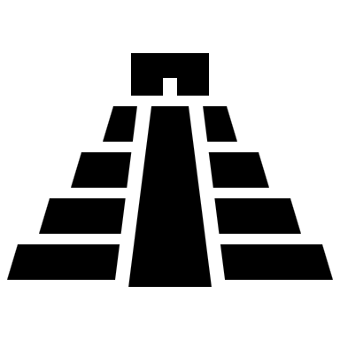

The focus this half term will be learning about the Ancient Egyptian civilisation. We’ll be looking at their beliefs, practices, key buildings and artefacts. Additionally, we will see how they have impacted civilisations today.

R.E.

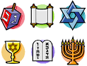

In RE, we will be looking at Hinduism, including the key beliefs of the Trimurti, importance of worship both at home and in the temple, and the role of Dharma in a Hindu’s daily life and service.

P.S.H.E
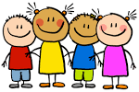

We will be learning about how to stay safe, our early warning signs and the rights and responsibilities we have as people in our ever-changing world.

P.E.
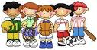

Our P.E. coaches will be teaching netball this half term, and the lessons with Mr. Sewards will be focused on developing fitness skills through HIIT, circuits and other intensive activities.

